PROJECT TITLE
IMPLEMENT CLIENT SCRIPT &UI POLICY (INCIDENT)

8. Project Demonstration Phase

Date: | 29.09.2026
Team ID: | SWTID-2026-2139
Project Name: | Implement Client Script & UI Policy (Incident)

8.1 Introduction
The Project Demonstration Phase is the final stage of the project. In this phase, the completed project “Implement Client Script & UI Policy (Incident)” is demonstrated using the ServiceNow Incident form.
The purpose of the demonstration is to show the implemented Client Script and UI Policy, explain their functionality, and demonstrate the resulting behavior of the Incident form.
The demonstration provides practical evidence that the developed project can be executed and presented successfully.

8.2 Objectives of Project Demonstration
The main objectives of the project demonstration are:
- To present the completed project.
- To explain the purpose of the project.
- To demonstrate the ServiceNow Incident module.
- To show the Client Script implementation.
- To show the UI Policy implementation.
- To demonstrate the condition-based field behavior.
- To demonstrate the validation and form changes.
- To present the final working result.
- To provide a demonstration video for project submission.

8.3 Demonstration Environment
The project demonstration was carried out using the following environment:

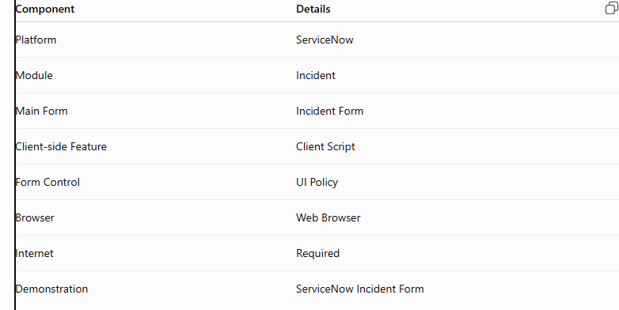

Client Scripts and UI Policies are client-side features used to control form and field behavior in ServiceNow.

8.4 Demonstration Procedure
The project demonstration follows a simple sequence.

Step 1 – Open ServiceNow
The ServiceNow instance is opened using a web browser and the required user account is accessed.

Step 2 – Open Incident Module
The Incident module is opened and the Incident form is selected.

Step 3 – Show the Developed Form
The Incident form is displayed with the fields used in the project.

Step 4 – Demonstrate Client Script
The relevant Incident values are changed to demonstrate the behavior controlled by the Client Script.

Step 5 – Demonstrate UI Policy
The required condition is applied and the corresponding field behavior is displayed.

Step 6 – Demonstrate Validation
The form is tested with the required condition to show the validation message and mandatory field behavior.

Step 7 – Show Final Result
The final Incident form is displayed after the required values are entered and the configured behavior is applied.

8.5 Demonstration of Client Script
The Client Script functionality is demonstrated by changing the relevant Incident field values.
The demonstration shows how the form responds when the specified condition occurs. The Client Script is used for client-side logic and can respond to events such as field changes or form actions.
The demonstration helps the viewer understand the relationship between the user's action and the resulting form behavior.

8.6 Demonstration of UI Policy
The UI Policy functionality is demonstrated by applying the required condition on the Incident form.
When the condition is satisfied, the selected field behavior changes according to the configured UI Policy Action. UI Policies can control field properties such as mandatory, visible, and read-only behavior.
This demonstrates how the Incident form dynamically responds to the selected condition.

8.7 Demonstration of Final Result
The final result is demonstrated using the Incident form.
The demonstrated result includes:
- Impact = 1 - High
- Urgency = 1 - High
- Priority = 1 - Critical
- Assignment Group = CAB Approval
- Assigned To = Howard Johnson
- A message indicating that urgency was set to High for a High impact incident.
The final form demonstrates the combined behavior implemented through the project.

8.8 Demonstration Video
A complete project demonstration video is prepared as part of the final submission.
The video demonstrates:
- Introduction to the project.
- ServiceNow Incident module.
- Incident form.
- Client Script functionality.
- UI Policy functionality.
- Condition-based field behavior.
- Validation behavior.
- Final successful result.
The completed demonstration video is uploaded to Google Drive, and the sharing permission is set so that the required viewers can access the video.
The Google Drive link is included in the final project submission.
https://drive.google.com/file/d/1QMJBFa4AOW-1JwQ_msFoQvAQzMKCrhvE/view?usp=drivesdk

8.9 Screenshots to Include in Phase 8
Screenshot 1 — Project Demonstration: Incident Form
Incident Form Used for Project Demonstration
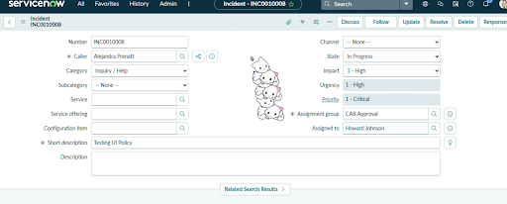

Screenshot 2 — Demonstration of Client Script/UI Policy
Client Script and UI Policy Behaviour During Demonstration
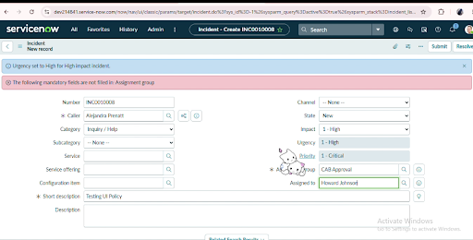

Screenshot 3 — Final completed form
Final Result of Project Demonstration
